**1. What are the various elements of the Excel interface? Describe how**

**They are used.**

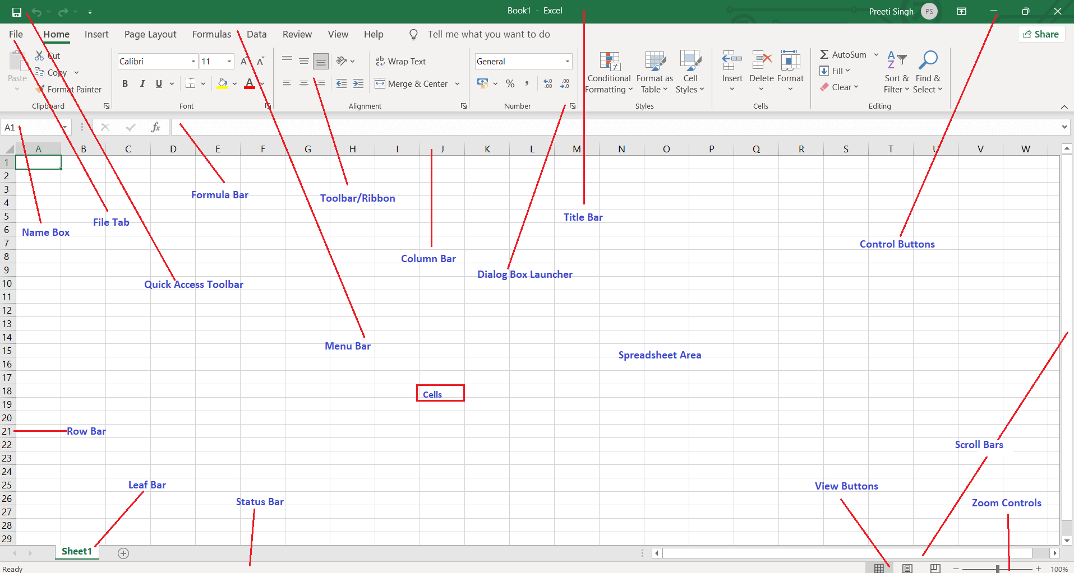

The following are the basic parts of the Microsoft Excel Window:

1. **Quick Access Toolbar:** We can customize this toolbar based on our preferred commands.
2. **File Tab**: To **open** or **save files, create new sheets, print sheets**, and perform other **file-related operations**.
3. **Title Bar:** It displays the **active document's name.**
4. **Control Buttons:** To change the **labels, minimize, maximize, share,** and **close the sheet.**
5. **Menu Bar:** **File, Insert, Page Layout, Formulas, Data, Review, View, Help**, and a **Search** Bar with a light bulb icon. These menus are divided into subcategories which simplify the distribution of information and analysis of calculations.
6. **Ribbon/Toolbar:** if we select the **"Home"** tab, we will see **cut, copy, paste, bold, italic, underline**, and **more** commands. In the same way; we can click on the **"Insert"** tab, we will see **tables, illustrations, additional, recommended graphics, graphics maps,** among others. On the other hand, if we select the **"Formulas"** option. **Insert functions, auto sum recently used, finances, logic, text, time, date,** etc.
7. **Dialog Box Launcher:** we can explore more options related to the concerned group.
8. **Name Box:** To Show the location of the active cell, row, or column. We have the option of selecting multiple options.
9. **Formula Bar:** To insert or edit the information/formula entered in the active cell.
10. **Scroll Bars:**  to **move the document's vertical** and **horizontal** views.
11. **Spreadsheet Area:** It includes all the **rows, cells, columns**, and **built-in data also** formulas of **arithmetic operations (add, subtract, multiply, etc.**
12. **Leaf Bar:** it says **sheet1** is shown. This sheet bar describes the spreadsheet which is currently being worked on.
13. **Column Bar:** columns. Begin with the letter **A** to **Z,** and then after **Z**, it will continue as **AA, AB,** and so on. The number of columns that can be used is limited to **16,384.**
14. Row Bar Cells: Begin with number one (1), and further rows will be added as we move the pointer down. There are a total of **1,048,576** rows available.
15. Cells:   
    Cells are those parallelepipeds that divide the spreadsheet into many pieces and first letter of the alphabet and the number one **(A1).**
16. **Status Bar:** displays critical information. It also indicates whether something is incorrect or whether the document is ready to be printed or delivered such as **sum, average, count, maximum, minimum,** etc.
17. **View Buttons:** different type of views are there as follow:

* **Normal View:** it contain Normal view displays the Excel page in normal view.
* **Page Layout View:** The Page Layout view shows the precise layout of an Excel page it will be printed.
* **Page Break View:** This displays page break preview before printing.

1. **Zoom control:** It enables us to **ZOOM-IN** or **ZOOM-OUT** a specific area of the spreadsheet icons with the symbols of **maximizing (+)** or **minimizing (-).**

**2. Write down the various applications of Excel in the industry.**

* Data entry
* Data management
* [Accounting](https://corporatefinanceinstitute.com/collections/accounting)
* [Financial analysis](https://corporatefinanceinstitute.com/collections/finance)
* Charting and graphing
* Programming
* Time management
* Task management
* [Financial modeling](https://corporatefinanceinstitute.com/resources/knowledge/modeling/what-is-financial-modeling/)
* Customer relationship management (CRM)
* Almost anything that needs to be organized!

**3. On the ribbon, make a new tab. Add some different groups, insert**

**commands in the groups and name them according to their commands**

**added. Copy and paste the screenshot of the steps you followed.**

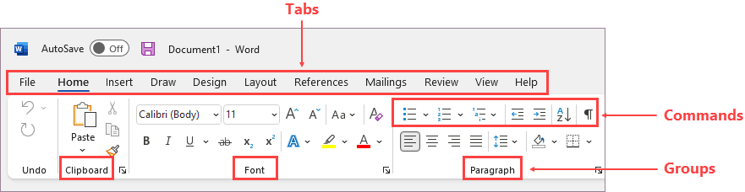

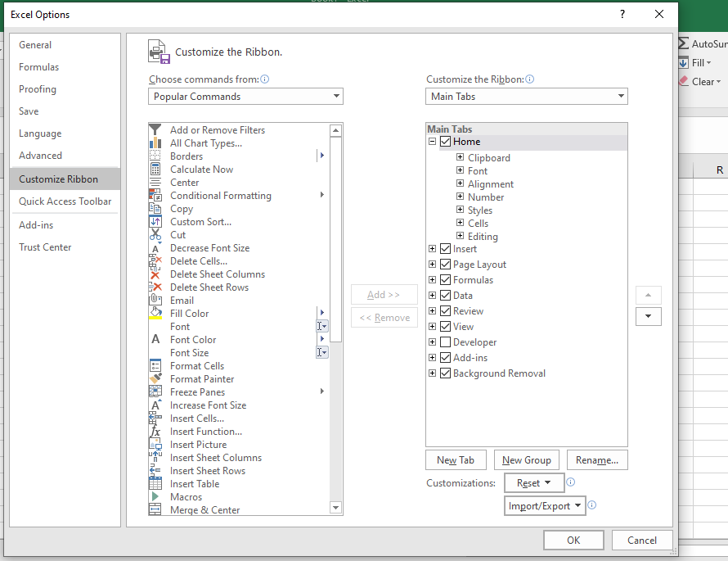

**4. Make a list of different shortcut keys that are only connected to**

**formatting with their functions.**

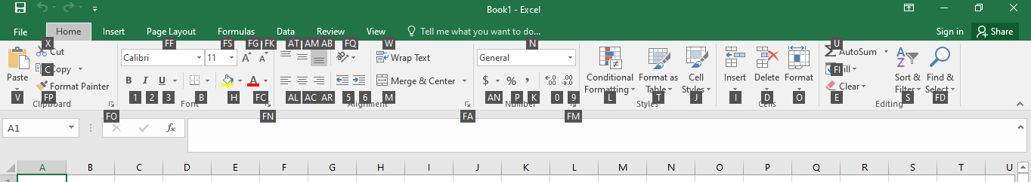

**Keyboard shortcut keys for formatting functions.**

**5. What distinguishes Excel from other analytical tools?**

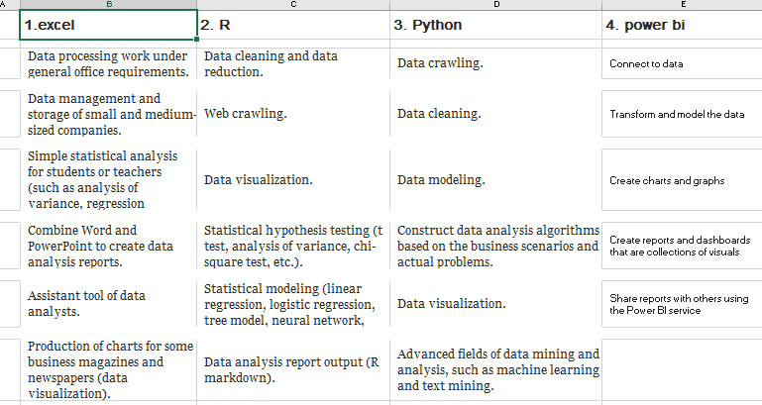

**6. Create a table and add a custom header and footer to your table.**

